**Year 12 ATAR PHYSICS 2020**

**Practical Test ELECTROMAGNETISM**

**Determining the field strength in a coil for an applied current.**

**Marks: /12**

**ANSWERS**

**Background:**

When a current flows through a solenoid (a coil), a uniform magnetic field parallel to the sides of the coil is produced. The strength of the field (B) depends upon the current (I) applied.

**Aim:**

To apply a current in a solenoid and calculate the field strength produced inside the solenoid.

**Equipment:**

Current balance kit

Two ammeters (0-5A)

Two 12 V DC power pack

2 Rheostats

Connecting leads

Solenoid

**Procedure:**

1. Set up the equipment as shown below. DO NOT TURN ON THE POWER.
2. BALANCE THE LOOP so it is horizontal.
3. When you have completed the circuit you **raise your hand so that your teacher can check it.**

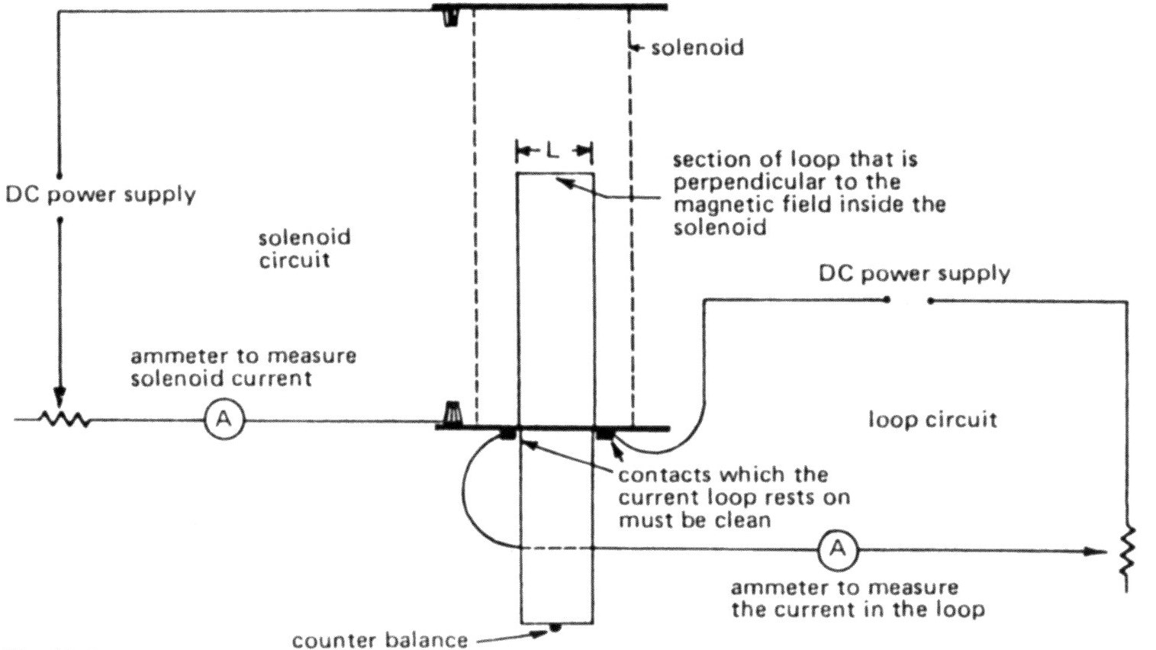

**/3**

**-1 mark for each error. Ensure correct polarity of connections to meters.**

**No loss of marks if equipment problem.**

**/4**

1. Place a piece of the nichrome wire on the end of the loop.

**/1**

**/4**

Mass of wire = **2/100 x 0.701 g = 0.01402g**

**( 0.0140g 3sf)**

1. Switch on the circuit. Adjust the current in the solenoid and in the loop so that the loop is again horizontal.

Record results here: solenoid current = _____________ Loop current = ______________

**/2**

**/4**

**Raise your hand so that your teacher can check your readings**

**-1/2 mark for each reading less than 2 significant figures**

1. Below is a diagram of the current balance setup:

SOLENOID

LOOP

**F= mg**

**/1**

**/4**

**F= IlB**

Complete the formulae in the boxes.

BOTH MUST BE CORRECT FOR 1 MARK

1. Using the correct current value, calculate the field strength in the solenoid.

**/4**

**1 correct I**

**1 correct** l

+/- 0.001

**1 mass in kg**

**1 answer**

**/4**

mg = IlB **B =** **1.402 x 10-5 9.8**

**I x 0.024m**

**B = 5.716 x 10-3/I T**

**= Ans (3sf, 2 ok) T**

ANSWER: A current of ______A in the solenoid produces a field strength of __________

**/1**

**1 correct solenoid current quoted**

**/4**